DATABASE ASSIGNMENT [40]
Create a simple database (relational database) for any business using MySql or Sql. The database must have the following:

- 5 entities
- Show relationships (1.M) among the entities
- Show the primary keys and foreign keys on the tables
- Write business rules for your database (2 PER ENTITY)

THE EXAMPLE
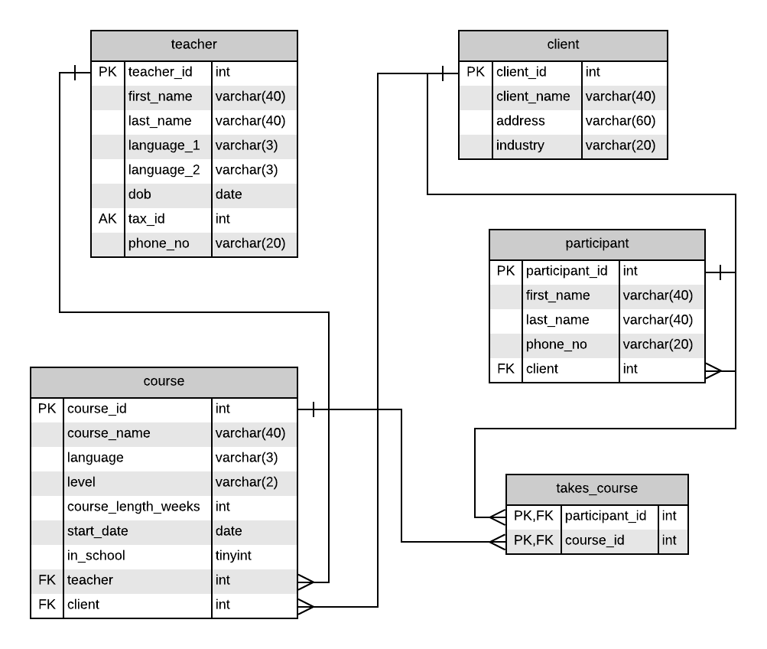
DUE DATE: 6 SEPTEMBER 2022
TIME : 10.55 AM

NO LATE SUBMISSION

